1. Top of FormThe president of a large university has been studying the relationship between male/female supervisory structures in his institution and the level of employees’ job satisfaction. The results of a recent survey are shown in the table below. Conduct a test at the 5% significance level to determine whether the level of job satisfaction depends on the boss/employee gender relationship.
   1. In the appendix is a Chi-squared test of independence using Excel. The null hypothesis is that the level of job satisfaction is independent of boss/employee gender relationship. Through calculations, a chi-squared value of 92.70868917 is obtained which leads to a p-value of 0.000000000000000000828795. Since the p-value is less than alpha of 0.05 we reject the null that the variables are independent of each other and conclude that the variables are dependent of each other. The level of job satisfaction does depend on the boss/employee gender relationship.
2. Using the Birthwgt file in the SASHELP directory (if you do not find it in the SASHELP directory, the data file is also posted on the datasets folder on blackboard so you can import it), examine if low birth weight and race are dependent. Also examine if low birth weight is related to married.
   1. Shown in the appendix are chi-squared tests of independence using SAS. The null hypothesis for part one is that low birth weight and race are independent of each other. When analyzing the charts, we can see the frequency rate for the Black race increases in relation to the other races as we shift the distribution from “no” to “yes” in terms of low birth weight. In contrast, as we shift the distribution from “yes” to “no” for the Black race, the frequency decreases. The chi-squared value is 834.5047 which results in a p-value of less than 0.0001. Since the p-value is less than an alpha value of 0.05 we reject the null and conclude that low birth weight and race are dependent of each other.
   2. The null hypothesis for part 2 is that low birth weight and married are independent of each other. When analyzing the charts, we can see the frequency rate for married “yes” increases with a low birth weight “yes”. This can also be interpreted as married “no” decreases with a low birth rate “yes”. The chi-squared value is 356.3369 which results in a p-value of less than 0.0001. Since the p-value is less than an alpha value of 0.05 we reject the null and conclude that low birth weight is dependent of married status.
3. A test was conducted to identify if “Weight_Status” and “BP_Status” are dependent. Interpret the results.
   1. The Chi-squared test under appendix, question 3, was conducted using SAS. The null hypothesis is that weight status and blood pressure status are independent of each other. As shown in the charts, we can see that blood pressure status fluctuates with each weight status. At underweight, the highest frequency is a normal blood pressure. In contrast, at overweight, the highest frequency appears to be high blood pressure. There are many examples, since with each different weight status, the blood pressure status changes. The chi-squared value is 385.3466 which results in a p-value of less than 0.0001. Since the p-value is less than an alpha value of 0.05 we reject the null and conclude that weight status and blood pressure status are dependent of each other.

Appendix:

Question 1:

|  |  |  |  |  |  |
| --- | --- | --- | --- | --- | --- |
| Level of Satisfaction | Male/ Female | Female/Male | Male/Male | Female/Female | Totals |
| Satisfied | 60 | 15 | 50 | 15 | 140 |
| Neutral | 27 | 45 | 48 | 50 | 170 |
| Dissatisfied | 13 | 32 | 12 | 55 | 112 |
| Totals | 100 | 92 | 110 | 120 | **422** |
|  |  |  |  |  |  |
| Level of Satisfaction | Male/ Female | Female/Male | Male/Male | Female/Female |  |
| Satisfied | 33.17535545 | 30.52132701 | 36.492891 | 39.81042654 |  |
| Neutral | 40.28436019 | 37.06161137 | 44.31279621 | 48.34123223 |  |
| Dissatisfied | 26.54028436 | 24.41706161 | 29.1943128 | 31.84834123 |  |
|  |  |  |  |  |  |
| Level of Satisfaction | Male/ Female | Female/Male | Male/Male | Female/Female |  |
| Satisfied | 21.68964116 | 7.893221424 | 4.999384502 | 15.46221225 |  |
| Neutral | 4.380713131 | 1.700358177 | 0.306806904 | 0.056918502 |  |
| Dissatisfied | 6.907962932 | 2.35494981 | 10.12678033 | 16.82974004 |  |
|  |  |  |  |  |  |
| Chi-Squared Value | 92.70868917 |  |  |  |  |
|  |  |  |  |  |  |
| P-Value | 8.28795E-18 |  |  |  |  |

Question 2:

|  |  |  |  |  |  |  |  |  |  |  |  |  |  |  |  |  |  |  |  |  |  |  |  |  |  |  |  |  |  |  |  |  |  |  |  |  |  |  |  |  |  |  |  |
| --- | --- | --- | --- | --- | --- | --- | --- | --- | --- | --- | --- | --- | --- | --- | --- | --- | --- | --- | --- | --- | --- | --- | --- | --- | --- | --- | --- | --- | --- | --- | --- | --- | --- | --- | --- | --- | --- | --- | --- | --- | --- | --- | --- |
| |  | | --- | | **Frequency**  **Expected** | | | **Table of LowBirthWgt by Race** | | | | | | | | --- | --- | --- | --- | --- | --- | --- | | **LowBirthWgt** | **Race** | | | | | | | **Asian** | **Black** | **Hispanic** | **Native** | **White** | **Total** | | **No** | 4821  4798.7 | 12115  12982 | 20623  20337 | 869  865.31 | 53431  52876 | 91859 | | **Yes** | 403  425.29 | 2018  1150.6 | 1516  1802.3 | 73  76.688 | 4131  4686.1 | 8141 | | **Total** | 5224 | 14133 | 22139 | 942 | 57562 | 100000 | |

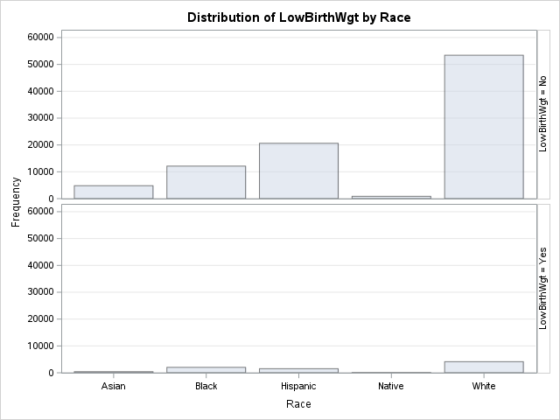

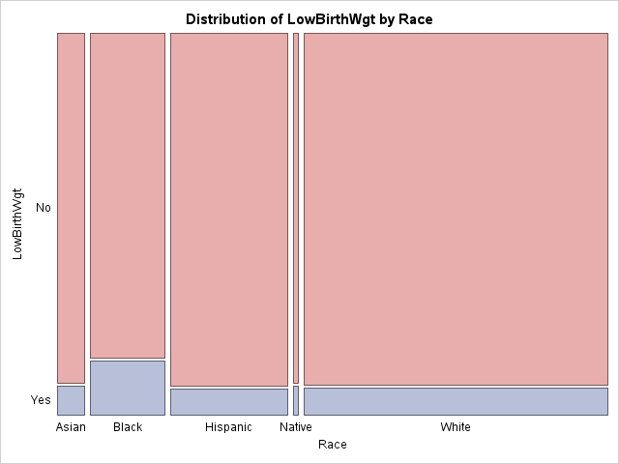

**Statistics for Table of LowBirthWgt by Race**

| **Statistic** | **DF** | **Value** | **Prob** |
| --- | --- | --- | --- |
| **Chi-Square** | 4 | 834.5047 | <.0001 |
| **Likelihood Ratio Chi-Square** | 4 | 720.0042 | <.0001 |
| **Mantel-Haenszel Chi-Square** | 1 | 274.8167 | <.0001 |
| **Phi Coefficient** |  | 0.0914 |  |
| **Contingency Coefficient** |  | 0.0910 |  |
| **Cramer's V** |  | 0.0914 |  |

**Sample Size = 100000**

|  |  |  |  |  |  |  |  |  |  |  |  |  |  |  |  |  |  |  |  |  |  |  |  |  |  |
| --- | --- | --- | --- | --- | --- | --- | --- | --- | --- | --- | --- | --- | --- | --- | --- | --- | --- | --- | --- | --- | --- | --- | --- | --- | --- |
| |  | | --- | | **Frequency**  **Expected** | | | **Table of LowBirthWgt by Married** | | | | | --- | --- | --- | --- | | **LowBirthWgt** | **Married** | | | | **No** | **Yes** | **Total** | | **No** | 61245  60471 | 30614  31388 | 91859 | | **Yes** | 4585  5359.2 | 3556  2781.8 | 8141 | | **Total** | 65830 | 34170 | 100000 | |

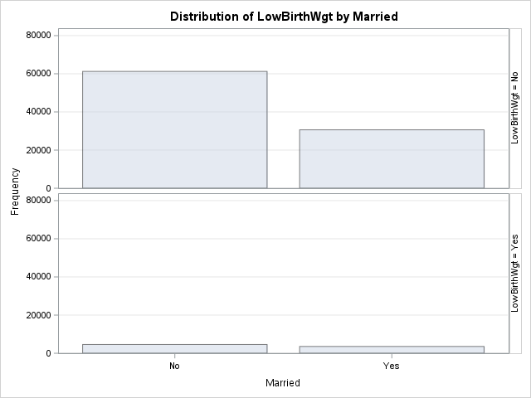

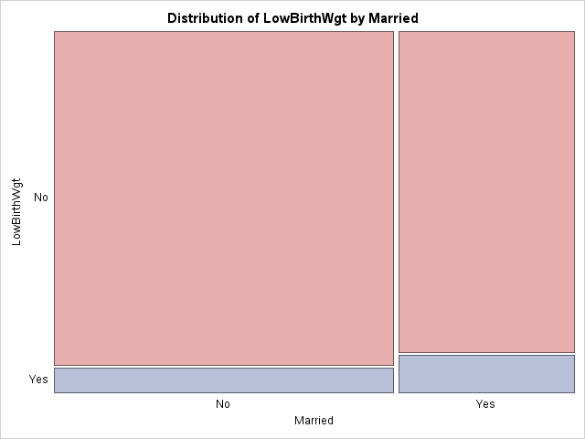

**Statistics for Table of LowBirthWgt by Married**

| **Statistic** | **DF** | **Value** | **Prob** |
| --- | --- | --- | --- |
| **Chi-Square** | 1 | 356.3369 | <.0001 |
| **Likelihood Ratio Chi-Square** | 1 | 344.6650 | <.0001 |
| **Continuity Adj. Chi-Square** | 1 | 355.8768 | <.0001 |
| **Mantel-Haenszel Chi-Square** | 1 | 356.3333 | <.0001 |
| **Phi Coefficient** |  | 0.0597 |  |
| **Contingency Coefficient** |  | 0.0596 |  |
| **Cramer's V** |  | 0.0597 |  |

| **Fisher's Exact Test** | |
| --- | --- |
| **Cell (1,1) Frequency (F)** | 61245 |
| **Left-sided Pr <= F** | 1.0000 |
| **Right-sided Pr >= F** | <.0001 |
|  |  |
| **Table Probability (P)** | <.0001 |
| **Two-sided Pr <= P** | <.0001 |

**Sample Size = 100000**

Question 3:

